***BRISINGA JOINT EXAMS***

***AGRIC PP2 SCHEME***

**ECTION A (30 MKS)**

1. Name four rabbit breeds reared in Kenya. (2 mks)

* ***California white.***
* ***New Zealand white***
* ***Flemish Grand***
* ***Chinchilla***

1. What is cropping in respect with fish farming (1 mk)

* ***Remove of fish of marketable size from the pond.***

1. State four practices carried out on fencing posts. (2 mks)

* ***Painting***
* ***Apply wood presentatives like old engine oil, creosole***
* ***Burn lightly/charring parts to be covered***
* ***Seasoning posts***
* ***Cover tops with plastic or metal sheet.***

1. Name two types of roughage. (1 mk)

* ***Dry roughage***
* ***Succulent rouphages***

1. Differentiate between mothering ability and prolificacy (1 mks)

* ***Good mothering ability***
* ***Ability of the female/mother to take care of the young ones-Prolifically***
* ***Ability to give rise to a large litter***

1. Give four disadvantages of inbreeding in livestock (2 mks)

* ***Reduces disease resistance***
* ***Reduces fertility in animals***
* ***May lead to abortions***
* ***Can bring loss of hybrid vigour***
* ***Reduction in performance***
* ***When done repeatedly, bad traits may express themselves easily***

1. Name one nutritional deficiency for each of the following livestock diseases.
2. Milk fever ( ½ mk)

* ***Low calcium.***

1. Bloat ( ½ mk)

* ***Lack of dry roughage during wet season***

1. Differentiate between drift and pen lambing. (2 mks)

* ***Drift lambing Pen lambing***
* ***Pregnant rules are put together***

***in one padlock and separated as they lamb-down.***

1. State four features on the animal which may predispose it to livestock diseases.

(2 mks)

* ***Species of the animal***
* ***Breed of the animal***
* ***Age of the animal***
* ***Sex of the animal***
* ***Colour of the animal***

1. outline four features that enable the Camel to survive in arid areas. (2 mks)

* ***Presence of hump to provide metabolic water***
* ***Long eye lashes to trap dust particles***
* ***Nose of lap to trap dust particles***
* ***Spongy hooves to avoid sinking in sand***
* ***Long limbs to elevate its body above the ground***

1. State four non-chemical methods of controlling ticks in cattle. (2 mks)

* ***Biology method***
* ***Burning infected pastures***
* ***Altering of ticks environment***
* ***Fencing***
* ***Hand picking***
* ***Starving ticks to death***

1. Give two reasons for hoof trimming in body of animals. (1 ½ mks)

* ***Facilitates easy movement***
* ***Controls foot rot disease***
* ***Prevents the ram from injuring the ewe during tupping***

1. State three functions of water in the body of animals (1 ½ mks)

* ***Component of body cells***
* ***Responsible for transportation of nutrients from one part of body to another.***
* ***Regulate body temperature through sweating and evaporation***
* ***Excretion of waste products from the body***

1. Give four factors that affect milk composition. (2 mks)

* ***Age of the animal***
* ***Condition of the animal***
* ***Stage of lactation and pregnancy***
* ***Completeness of milking***
* ***Breed differences***

1. a) Name the goat breed which is brown in colour with white strips running down the face to the nose ( ½ mk)

* ***Toggen burg***

1. State four rearing practices that necessitate handling of piglets. (2 mks)

* ***Teeth clipping***
* ***Creep feeding***
* ***Castration***
* ***Ear notching***
* ***Weighing***
* ***Tatooing***

1. State four maintenance practices carried out on a fish pond. (2 mks)

* ***Repairing the dyke***
* ***Clearing the pond and necessary***
* ***Remove undesirable vegetation***
* ***Removing silt***

1. Outline four merits of an embryo transplant when breeding livestock. (2 mks)

* ***Possible to implant embryo from high quality female***
* ***Stimulates milk production in a female that was not ready to produce milk.***
* ***Highly productive female can spread over large urea.***
* ***Easy to transport embryos in test tubes than whole animal.***
* ***Embryos can be stored for long awaiting recipient.***

1. Give two livestock diseases controlled through artificial insemination. (1 mk)

* ***Bruceilosis***
* ***Vaginitis***
* ***Ochaitis***

**SECTION B (20 MKS)**

**Answer all questions in this section.**

1. The diagram below represents a livestock parasite. Use it to answer the questions that follow.

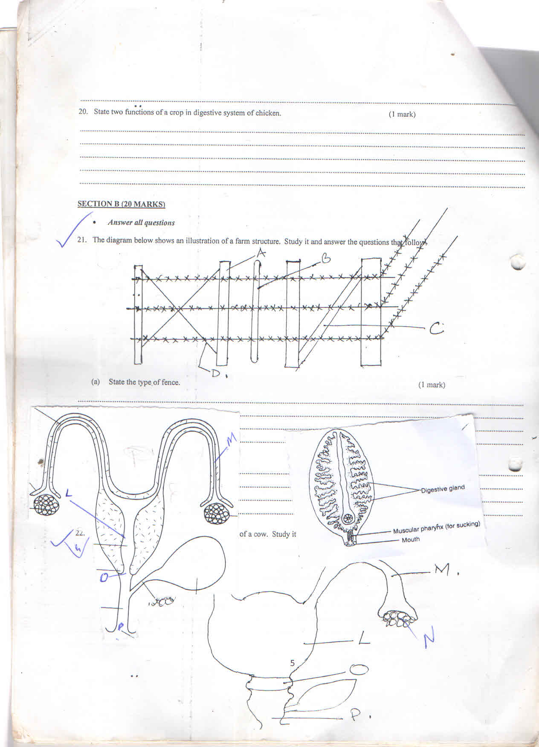

1. Identify the parasite (1 mk)

* ***Liverfluke***

1. Which part of the animal’s body is affected by above parasite (1 mk)

* ***Liver***

1. State three symptoms that may be observed (3 mks)

* ***Loss of weight and emaciation***
* ***pot- bellied***
* ***Animal suffer indigestion***
* ***Damage to liver tissues and hemorrhage***
* ***Anaemia condition***
* ***Swollen and painful abdomen***

1. The diagrams below represent some farm tools and equipment. Study them and answer the questions that follow.

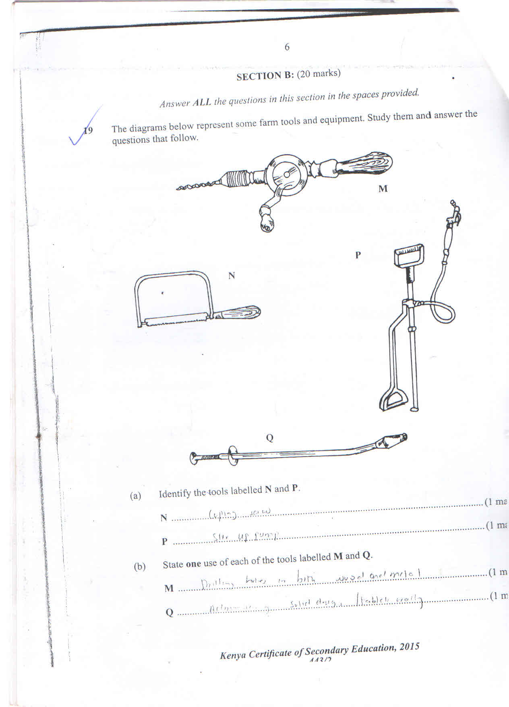

1. Identify the tools labelled N and P
   * N: ***Coping saw*** (1 mk)
   * P: ***Stir up pump***
2. State one use of each of the tools labelled M and Q
   * M: ***Drilling holes*** (1 mk)
   * Q: ***Administering solid drugs.*** (1 mk)
3. Explain one maintenance practice carried out on the equipment labelled P.(1 mk)

* ***Clean thoroughly after use to prevent contamination.***

1. The diagram below shows reproductive system of a cow. Study it and answer the questions that follow.



1. Name the parts labelled. (2 mks)

L: ***Uterus/womb***

M: ***Fallopian tube***

O: ***Cervix***

P: ***Vagina***

1. State the functions of parts labelled M and L (2 mks)

* ***M- where fertilization takes place***
* ***O- Where Semen is deposited***

1. State any advantage of inbreeding livestock production (1 mk)

* ***Brings loss of hybrid vigour***
* ***Decline in infertility***
* ***Reduction in production/performance***
* ***High rate of prenatal mortality***

1. The diagram below shows an illustration of a farm structure.



1. State the type of fence (1mk)

* ***Barbed wire fence***

1. Name the parts labelled (4 mks)

A: ***Standard post***

B: ***Dropper***

C: ***Strut***

D: ***Strainer***

**SECTION C (40 MKS)**

**Answer any two questions from this section in spaces provided after question 25 .**

1. a) Explain five roles of livestock farming in the economic development of Kenya.
2. mks)

* ***Source of food***
* ***Source of income***
* ***Cultural used***
* ***Status symbol***
* ***Medium of exchange***
* ***Social ceremonies***
* ***Recreational purpose***
* ***Animal power***

b) Briefly explain the functions of worker bee in a bee colony. (5 mks)

* ***Feed the queen; drone and brood***
* ***Protect the hive from intruders***
* ***Collect nectar, pollen, tree resigns, gum and water***
* ***Build comps and seat cracks and crevices in hive***
* ***Clean the hive***
* ***make honey and bee’s wax***

c) State five harmful effects of lice in pigs. (5 mks)

* ***Irritation leading to scratching on objects***
* ***Emaciation/loss of production***
* ***Wounds causing secondary infection***
* ***Retended growth***

***introduce Toxins harmful to pigs***

* ***Heavy infection leads to loss of health***
* ***Suck blood leading to anaemia***

1. a) State five signs of external parasite infestation in livestock. (5 mks)

* ***Parasites seen attacked onto various sites of animals***
* ***Animal appears emaciated***
* ***Causes irritating and discomfort to animal***
* ***Cause damage to skin***
* ***Reduction in production***

b) Explain five factors that should be considered when siting a farm store. (5 mks)

* ***Vermin foot***
* ***Well ventilated***
* ***Water proof\Easy to clean***
* ***50cm above the ground***
* ***Completely sealed***

c) Describe the cycle of a four stroke petrol engine (10 mks)

***i. Induction***

* ***Piston moves down***
* ***Wet valve opens – draws fresh petrol vapour and air into***

***ii. Compression***

* ***Inlet valve closes***
* ***Piston moves up the cylinder***
* ***Compresses fresh fuel mixture***

***iii. Power stroke***

* ***Fuel mixture tally compressed***
* ***Spark produced at spark plug***
* ***Fuel mixture ignites***
* ***Piston moves down the cylinder***

***iv. Exhaust stroke***

* ***Piston moves up the cylinder to eliminate burned fuel***
* ***Exhaust valve open***

1. a) Describe ten characteristics of a good layer. (10 mks)

* ***Perimeter fence constructed along boundaries to demarcate farm land from neighbours***
* ***Keep off wild animals and other intruders from outside farm***
* ***Separate crop fields from pastures, facilitating mixed farming***
* ***Used to divide pasture into paddocks facilitating controlled grazing systems***
* ***Controls movements of animals and people prevent formation of unnecessary paths in farm***
* ***Controls spread of diseases and parasites keeping off wild and stray animals, from farm***
* ***Help isolate sick animals, from rest of the herd to prevent spread of diseases***
* ***Provide security to homestead and farm animals***
* ***Help prevent breeding by rearing different animals***

b) Discuss new castle under the following subheadings.

i. Symptoms of attack. (5 mks)

* ***Difficulties in breathing i.e produce harsh, gloating, rasping sound***
* ***Breaks remain wide open and necks are strained***
* ***Birds stand with eyes closed***
* ***Birds’ loose appetite***
* ***Nasal discharges forcing birds to shake their heads to clear***

ii. Control measures. (5 mks)

* ***Quarantine***
* ***Vaccination***
* ***No known treatment for disease***
* ***Kill effected birds.***

**THIS IS THE LAST PRINTED PAGE.**